Title (14pt,bold)
Firstname Lastname^{1,*}, Firstname Lastname² and Firstname Lastname² (12pt)
¹Affiliation1 (11pt, italic)
²Affiliation2
*Correspondence: e-mail@e-mail.com; Tel.: 03 12 12 12 12

Keywords: keyword1; keyword2; keyword3; keyword4; keyword5

Please use Palatino linotype (11pt) for your extended abstract (1 page maximum). The margins (2cm) must also be maintained. Please provide the organizers with a pdf version of your contribution to avoid any changes in the layout before March, 12th 2019.

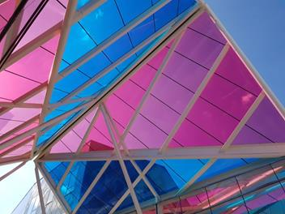
Figure: Figure caption (11pt) if necessary

References
[1] J. van der Geer, J.A.J. Hanraads, R.A. Lupton, The art of writing a scientific article, J. Sci. Commun. 163 (2010) 51–59.
[2] W. Strunk Jr., E.B. White, The Elements of Style, fourth ed., Longman, New York, 2000.
[3] G.R. Mettam, L.B. Adams, How to prepare an electronic version of your article, in: B.S. Jones, R.Z. Smith (Eds.), Introduction to the Electronic Age, E-Publishing Inc., New York, 2009, pp. 281–304.

